Create a new Project:
Project Name :BehaveBDD with Page object Model
1.Add Features Package and Steps package
2.Add the logs and utilities directory
3.Add behave and allure behave,selenium,webdriver-manager python package.
Steps:
Add behave.ini in the root directory
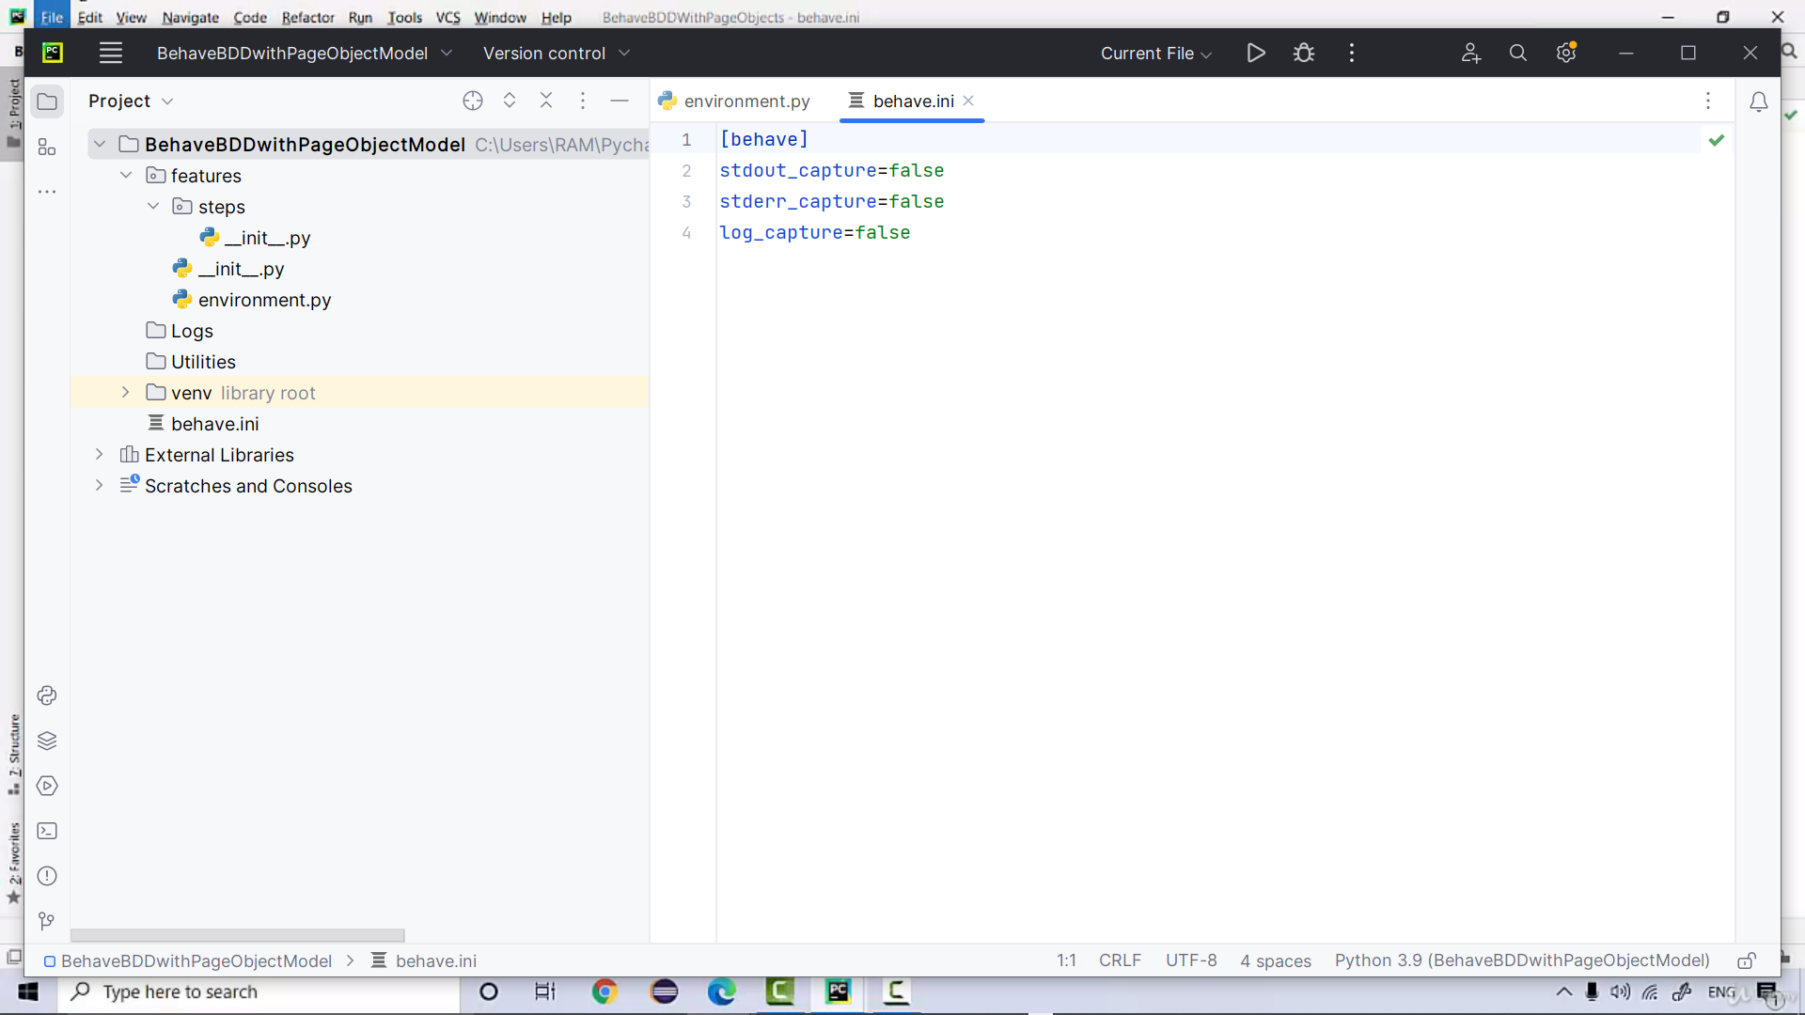
Add ConfigReader and LogUtil file in the Utilities folder
Create a new directory inside features as pageobjects
Create a Basepage which contains actions performed commonly
Create a configuration data in the root directory
create a registration feature in features
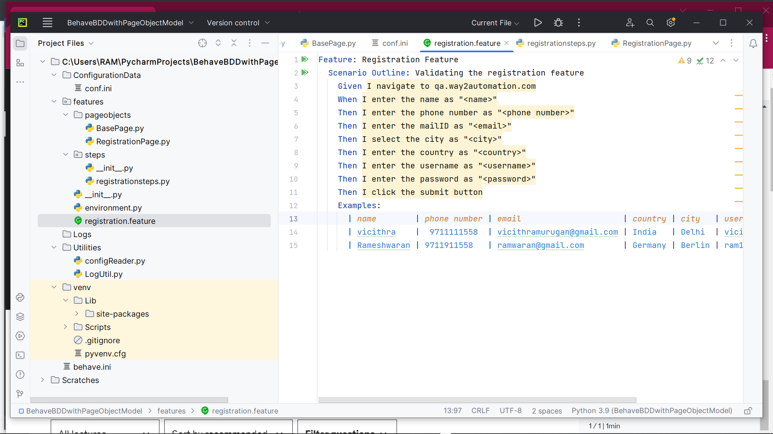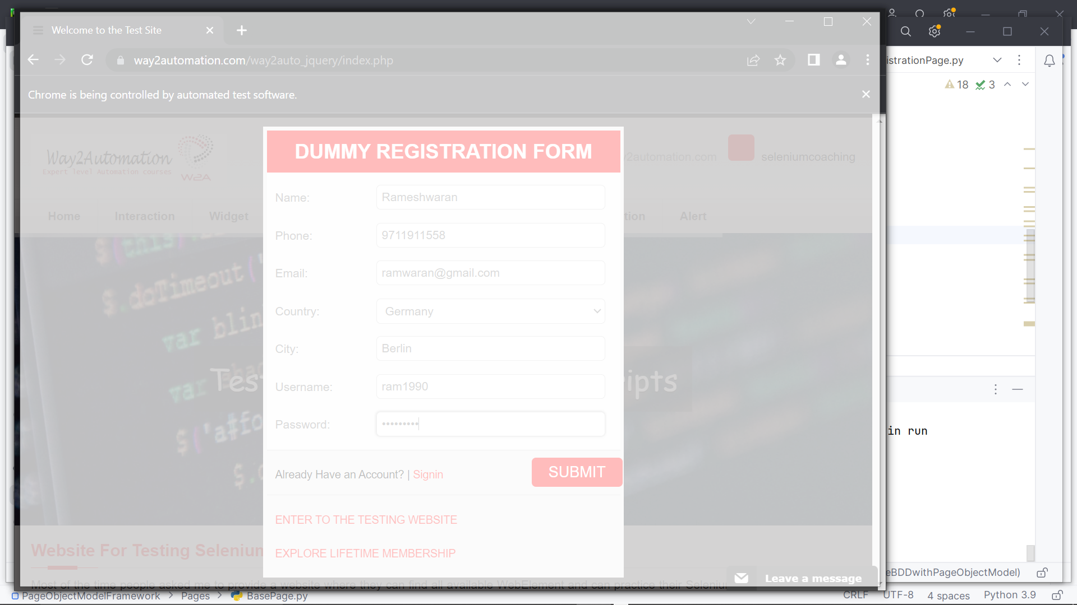
All files are executed successfully.
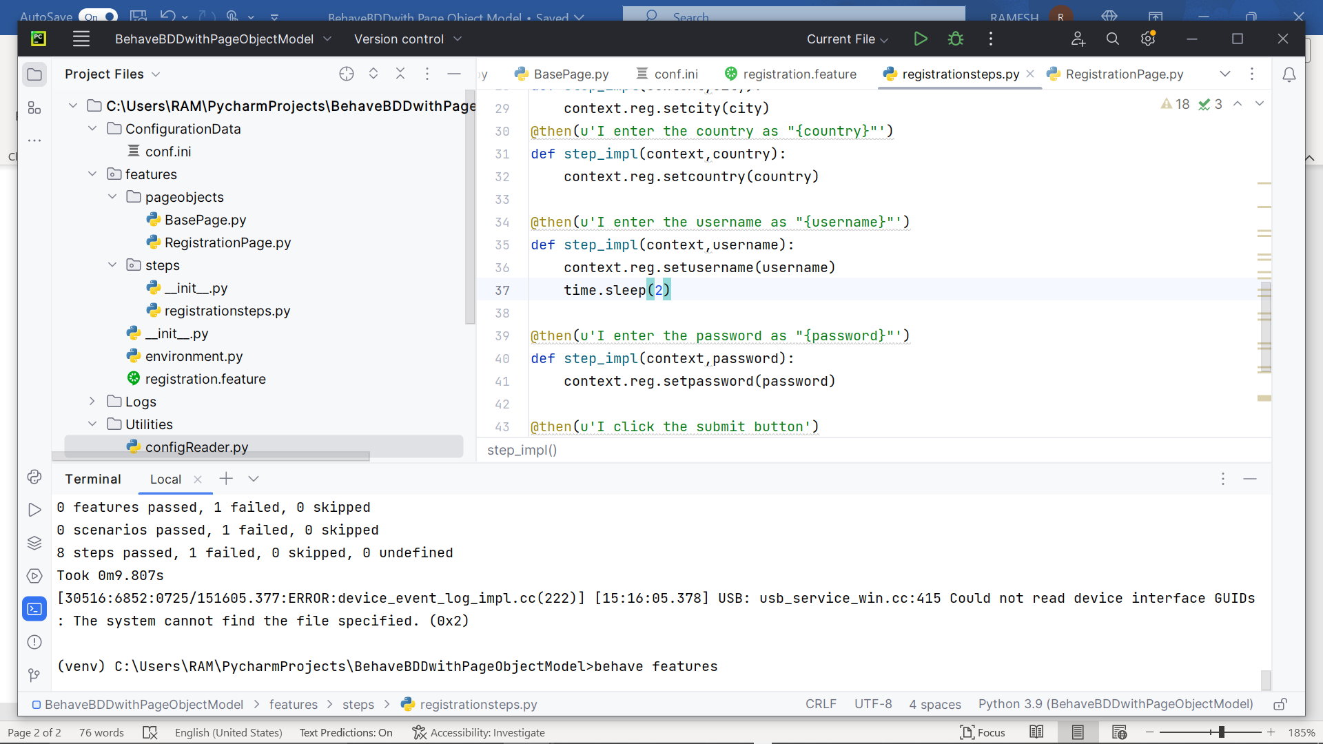
Running the test for multiple users
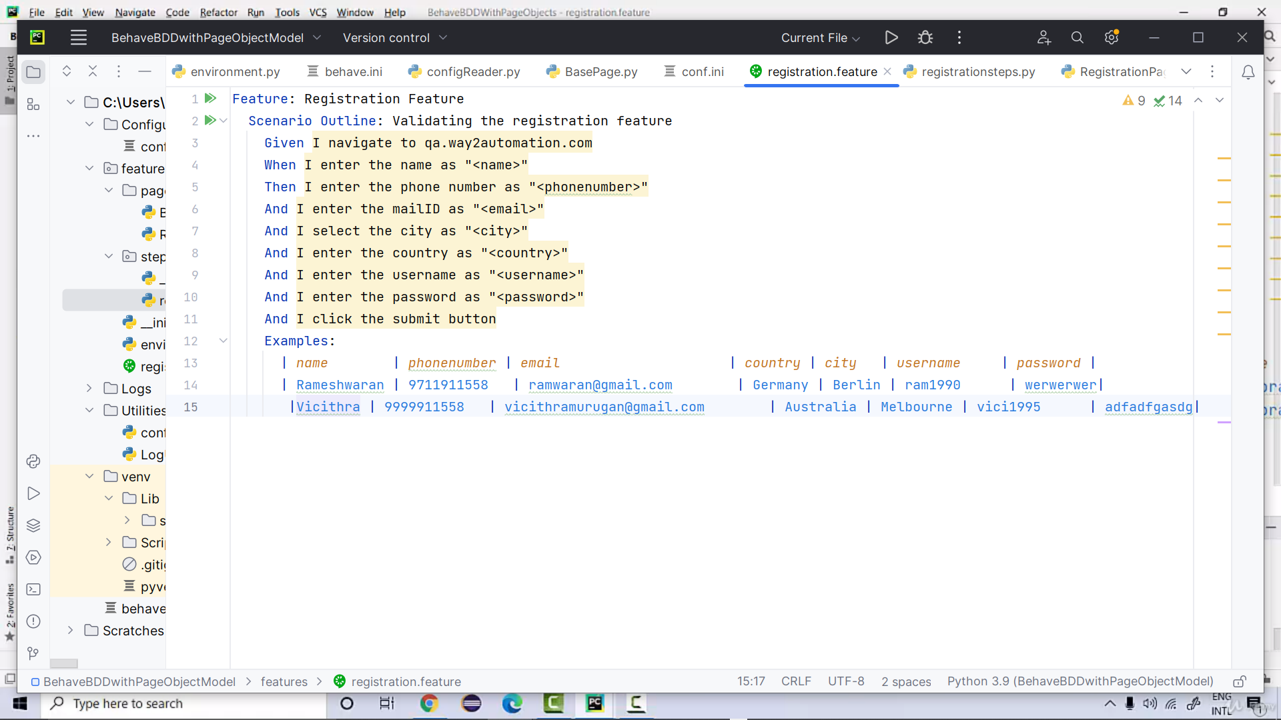

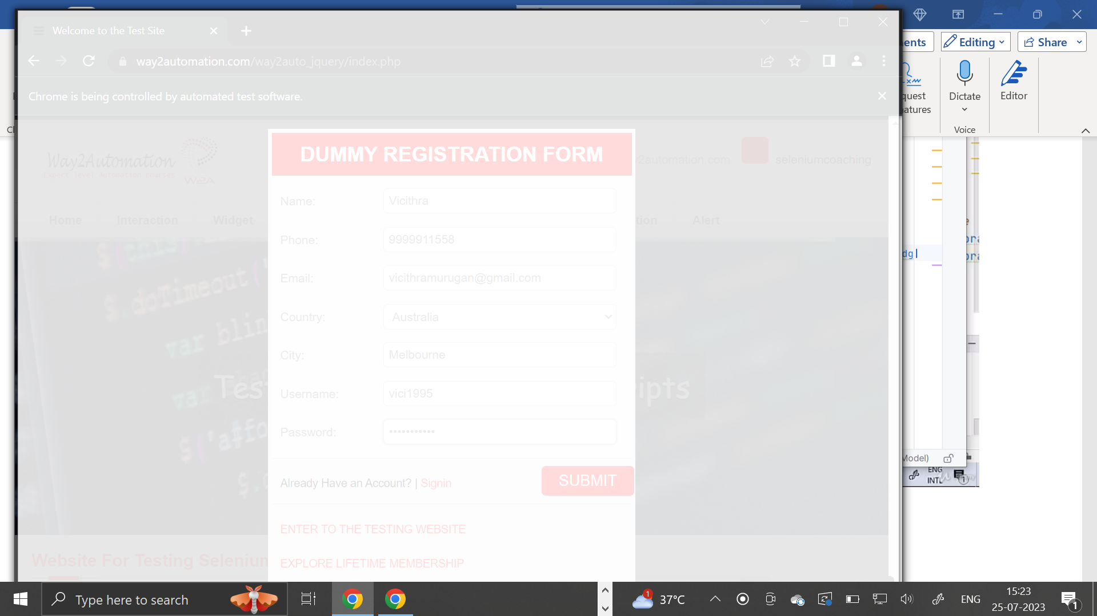
Generating Allure reports:
>behave -f allure_behave.formatter:AllureFormatter -o allure_reports/features
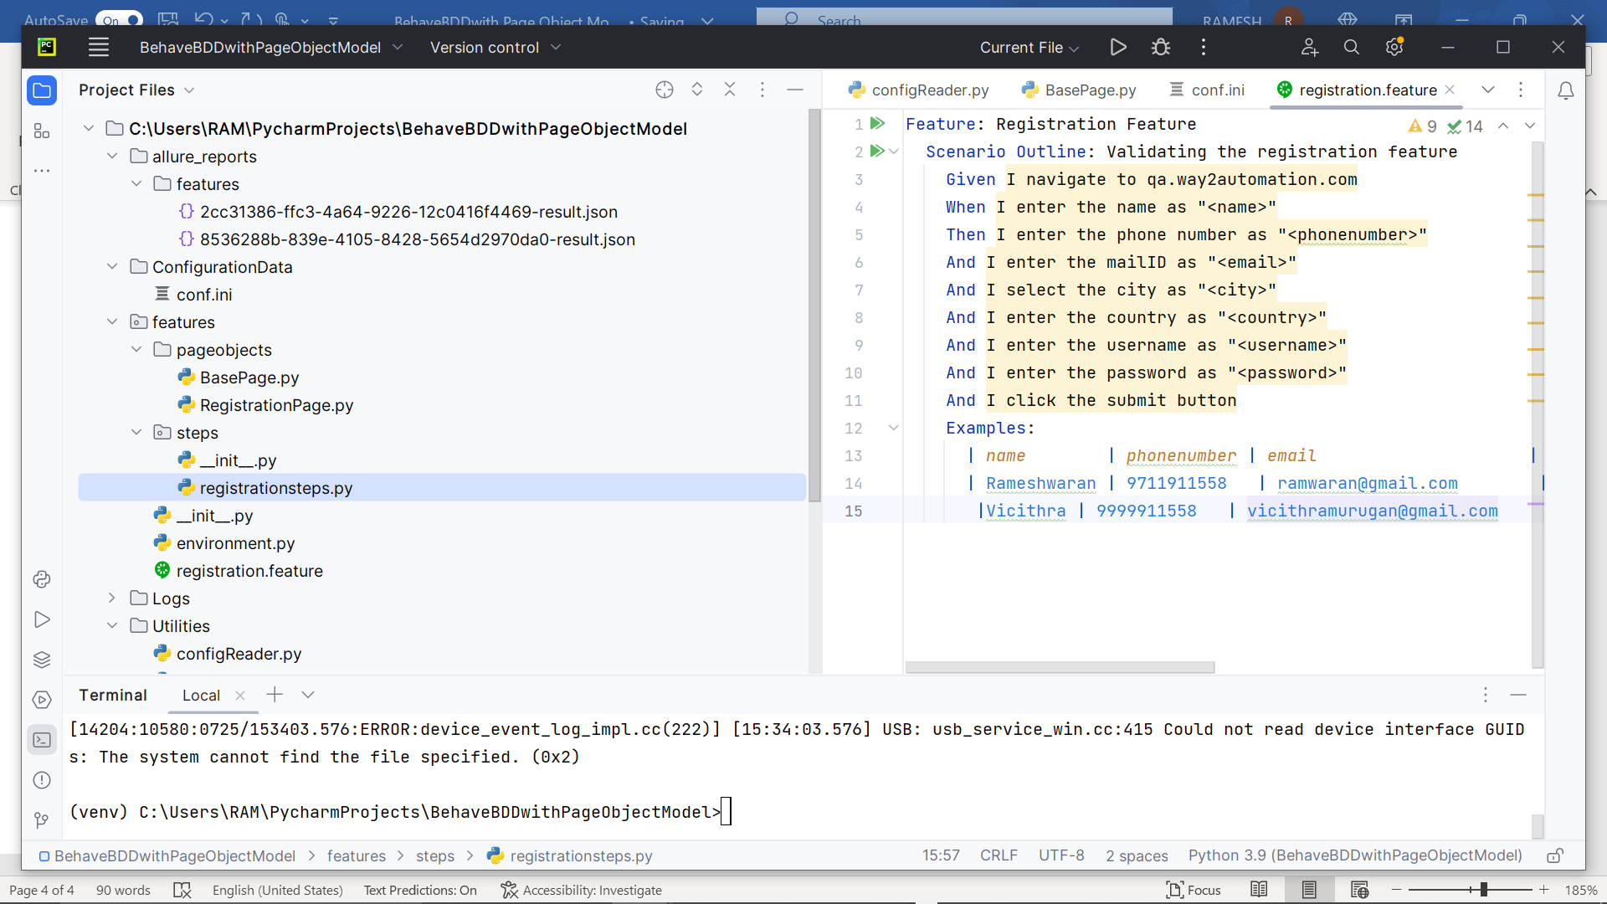
Logs Generated
